For H2 database :-

1. Please uncomment the following from application.properties :-

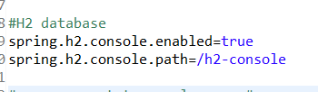

1. Uncomment h2 dependency from the pom.xml.
2. Go to <http://localhost:9090/h2-console>
3. Enter following details :-

